Name
Institutional Affiliation
Course
Date
Effect of price increase on inferior goods on the welfare of the consumer.
According to (Demand 1951), Inferior goods are those whose demand comes down when the income of individuals rises. An example of this case can be a cheap car in the market or cheap Television. There are three different ways measuring the effect of price increase on an inferior product in the market in the welfare of the customer.
The demand curve
Measurements are carried according to the formation demand curve is trending, on how the increase in price affects consumers' choice, and finally, the way income affects customers' choice. These factors or measurement dictates how the product will come farewell in the market. These factors mostly affect each other in different ways. In this article, we will discuss the comparison and contractions of these three ways of measurement (Demand, 1951).
Generally, an increase in the price of inferior goods affects demand. Change in the cost of products commands the budget to shift. Increasing the price of an inferior good as the price of a normal good remains the same, tends to change the customer's preference. Consumers will now start purchasing standard goods rather than inferior good. These phenomenal can be understood by the diagram below.
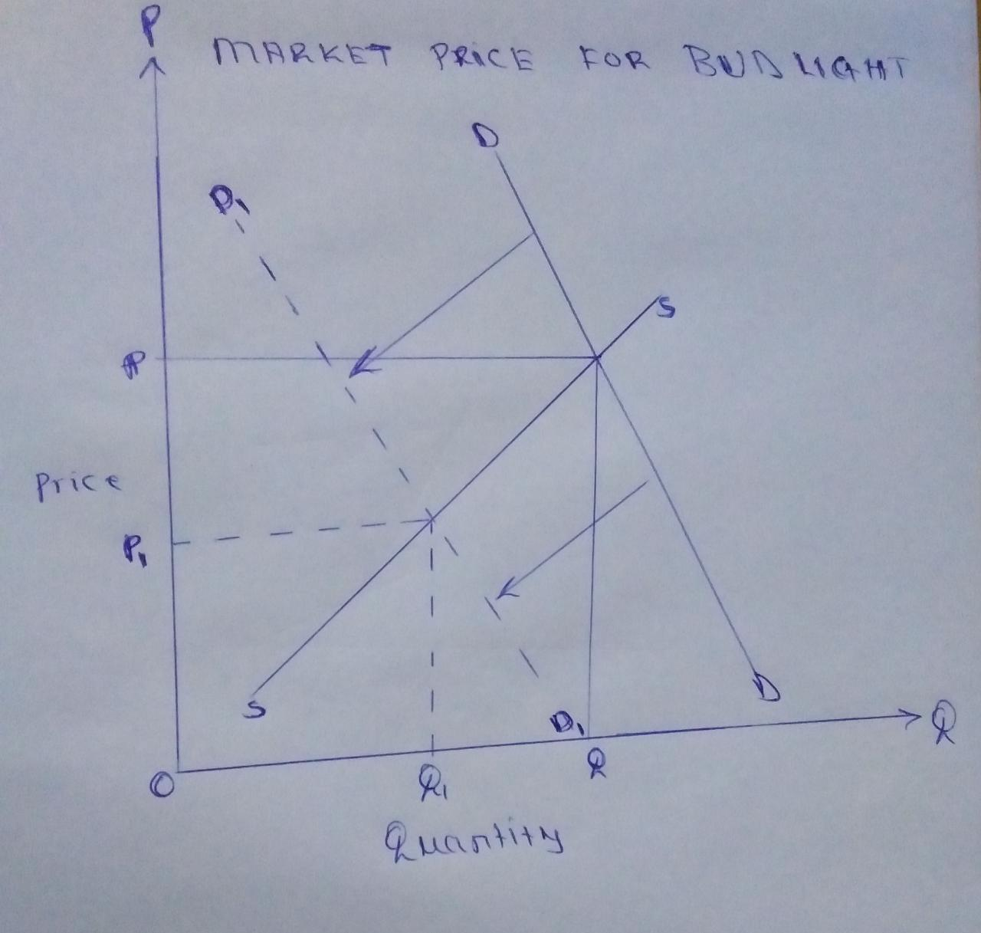
Given the price of an inferior product is raised while that of a normal not shaken, these leads to equilibrium on the price, yet the quality differs. Thus, the consumer will go for better quality rather than the one they used to. The change in the demand curve is evidence of increasing the price of an inferior product to the welfare of the customer. The magnitude and direction of the change in quantity demanded due to the rise in the cost of the inferior goods increases the demand of normal goods due to the quality (as the price rises the budget constraint on the previous section shifts.
Change in the income of the consumer
Concerning the inferior goods, the effects of income dominate the impact of substitution, leading to consumers purchasing more goods and fewer substitute items when there is an increase in the price. Besides, the change in income affects consumer choice if an individual has to choose between a lottery ticket at $60 and asleep overnight of $300 in a single night.
While he or she has a couple of dollars per year to spend between these two, he needs utility and marginal utility to think and apply the decision rule of price to the marginal utility that is supposed to be equal. He has to consider the inferior decision every time the two pop up. If the sleep overnight is inferior, he has to go it over, and if the lottery tickets are inferior, he will go for sleep overnight. If utility-maximizing's original budget was on the new budget, anew choice has to be made because both products are normal. When either of the options becomes inferior, the other products become the priority (Demand, 1951). The horizontal dashed vertical lines extend via point enables the customer to categorize whether the product is normal or inferior.
All these choices are theoretically possible, depending on is personal preferences. With an increase in price, a common reaction is to purchase both preferences.
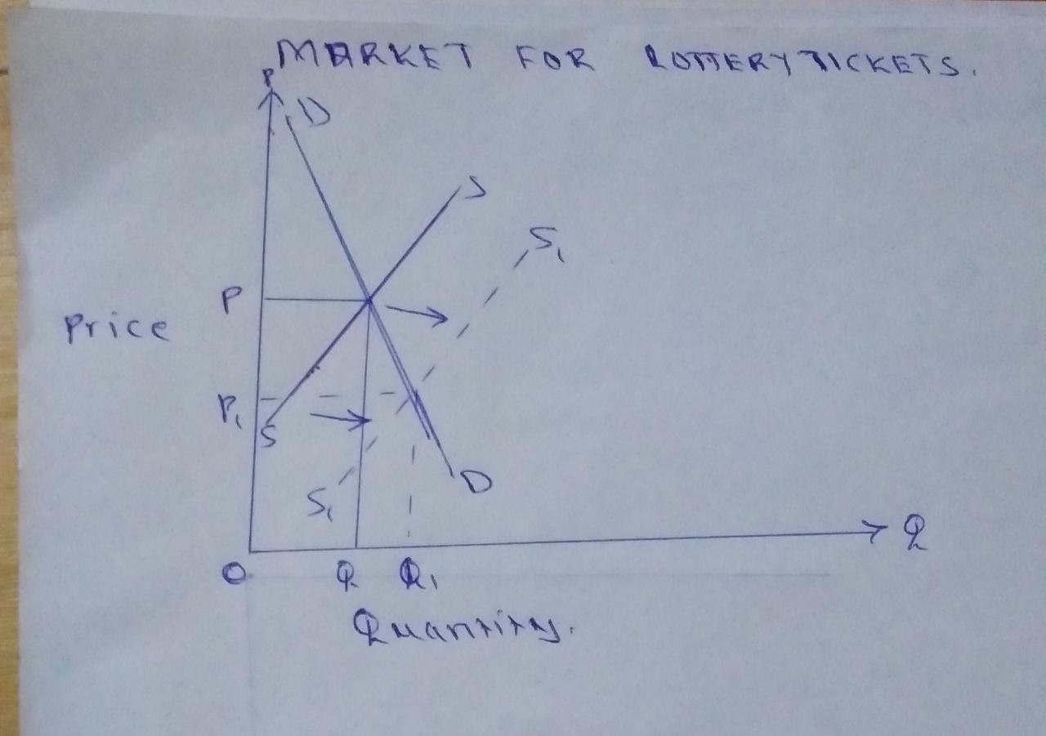

Prices of the product
Finally, the product's prices may have an impact on the preferences a customer wants, or it might not have any effect. Our case study, a student, is yawning to buy tea. In this case, an increase in the price of tea wouldn't affect the tea prices but would affect the number of cups of the tea the student would buy. An increase in the price of a teacup will act as a hinge pull the prices and the budget inwards. In this diagram, the horizontal nor the vertical axes are not labeled (Liebhafsky, 1961). When the price remains the same, no shift will be observed, but when the prices increase, the budget constraints shift to the left. As the price increases, the student’s decisions depend on the new budget constraints. More often, when the price increases, the customer tends to spend less-substitution effect.
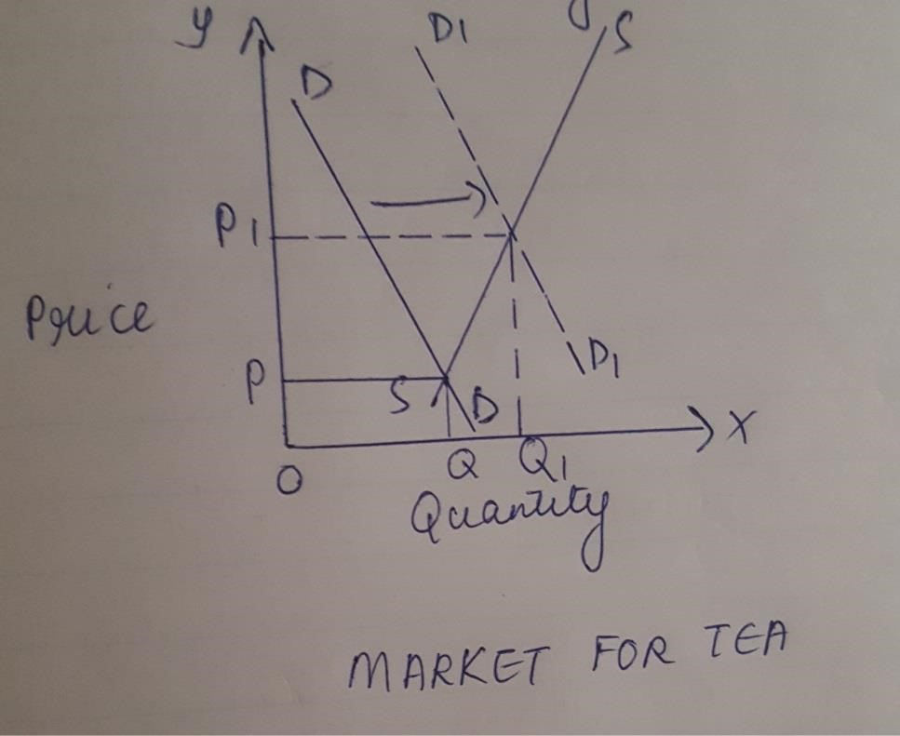
Therefore, a change in consumers' tastes leads to a shift in the demand curve. A change in the price of a commodity leads to a movement along the demand curve. Thus the two products correspond, and any shift in quality or prices will lead to changes in demand and supply of the commodities.
Reference
Demand, E.O., 1951. Managerial economics.
Liebhafsky, H.H., 1969. New thoughts about inferior goods. The American Economic Review, 59(5), pp.931-934.

